 | 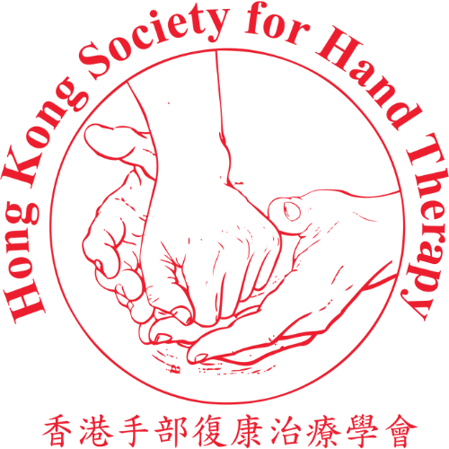
HKSHT 20th Anniversary Symposium cum 11th APFSHT Pre-Congress Scientific Meeting: Advancing Practice through Legacy, Innovation, and Collaboration in Hand Therapy
Tips and Tricks Session Submission Form
Extended Submission Deadline: 31 August 2026 (23:59 HKT)
Please provide your contact info. and Tips and Tricks details by completing the form.
All submission must be written in English.
Please send the completed form via email to: handtherapyhk@gmail.com

Presenter Information
Full Name: | __________________________________
Email Address: | __________________________________
Contact Phone Number: | __________________________________
Institution/Organization: | __________________________________
Country/Region: | __________________________________
Profession/Position: | __________________________________

Tips and Tricks Presentation Details
Title:_________________________________________________________________
Short Summary (in English, 250-word limit)

Submission Declaration
I confirm that:
☐ | I understand that registration for the symposium is required.

Presenter’s Signature: | Date:
_______________________ | _______________________

Please attach your presentation materials, either photos, videos or short summary in pdf format in your email.
Presentation format: - Speaking time: 3 minutes - Maximum: 5 slides
The Organizing Committee of the Hong Kong Society for Hand Therapy will review all applications. Notifications of acceptance or regret will be sent by October, 2026.

