 | 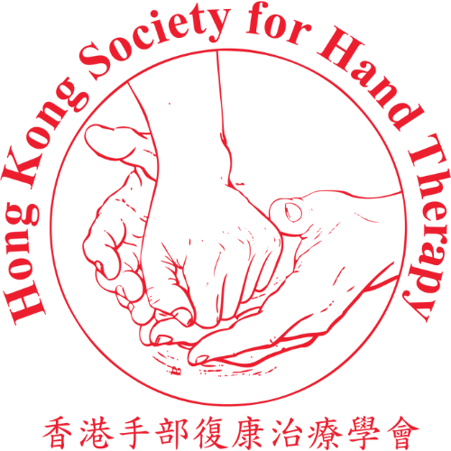
HKSHT 20th Anniversary Symposium cum 11th APFSHT Pre-Congress Scientific Meeting: Advancing Practice through Legacy, Innovation, and Collaboration in Hand Therapy
Abstract Submission Form
Extended Submission Deadline: 31 August 2026 (23:59 HKT)
Please provide your contact information and abstract details by completing the form.
All abstracts must be written in English.
Please send the completed form via email to: handtherapyhk@gmail.com

Presenter Information
Full Name: | __________________________________
Email Address: | __________________________________
Contact Phone Number: | __________________________________
Institution/Organization: | __________________________________
Country/Region: | __________________________________
Profession/Position: | __________________________________
Is the presenter same as the first author of the abstract? | ☐ Yes  ☐ No  If no, please provide the above information in your email.

Abstract Details
Abstract Title:_________________________________________________________
Abstract Type (select one):
☐ Oral Presentation
☐ Poster Presentation
☐ Either Oral or Poster Presentation
Abstract Content (in English, 500-word limit)
(Please include your introduction, Materials and Methods, Results, Conclusions in your content)

Keywords (3–5 words, in English):
Has this abstract been submitted or presented at other conferences? | ☐ Yes  ☐ No  If yes, please provide the name and date of the conference(s):  _____________________________

Submission Declaration
I confirm that:
☐ | This abstract is original work or has been appropriately authorized.
☐ | All information provided is accurate, and if accepted, I will submit a brief biography, portrait, presentation files, or posters as required.
☐ | I understand that registration for the symposium is required.

Submitter’s Signature: | Date:
_______________________ | _______________________

Please attach your abstract in your email, which will be included in the program book if your submission is accepted.

The Organizing Committee of Hong Kong Society for Hand Therapy will review all submitted proposals before notifications to selected parties. Organizing Committee welcomes proposals previously submitted to other meetings. Notifications (acceptances/regrets) will be sent by October, 2026.

